ZOO-102 Current papers fall 2020-2021
Q1: Reproductive Patterns
• The pattern of egg laying and development of young ones. • In all invertebrates and vertebrates one of the three patterns. • Oviparity • Ovoviviparity • Viviparity
Q2: Define oviparous animals? 2marks
Oviparous • Which lay eggs and development outside the body of animals • Fertilization may be internal or external • Majority of invertebrates and many vertebrates are oviparous • Parental care may be or may not
Q3: Define ovoviviparous animals? 2marks
Ovoviparous • Which eggs are retained into the body but the young one gets all its food from yolk of egg • Fertilization is internal • Development also internal • Invertebrates: Annelids, brachiopods, gastropods • Vertebrates: Fishes and reptiles
Q4: Define viviparous animals? 2marks
Viviparous • Which eggs develops into the body and the young one gets its nourishment from mother • Fertilization is internal • Development also internal • Invertebrates: Scorpions • Vertebrates: most mammals and elasmobranch fishes, few amphibians and reptiles
Q5: Difference between holometabolous Metamorphosis AND Hemimetabolous Metamorphosis)
Holometabolous Metamorphosis | Hemimetabolous Metamorphosis
This is also called complete metamorphosis  • In about 88% insects  • It is the type of metamorphosis which separates the physiological process of growth from differentiation and sexual stages  Each process is completed without intervention of other stage | • It is also called gradual incomplete metamorphosis
Four stages  • Egg  • Larva  • Pupa  • Adult  • E.g., Insects | • It is the mode of development of certain insects with three distinct stages  • Egg  • Nymph  • Adult  • E.g., Aphid, grasshopper, cockroach
Egg Stage  • First stage of insect life cycle • Development starts after fertilization or sometime without fertilization • Early embryonic development completed at this stage • Egg stage is very short but in some cases undergo diapause | Egg Stage  • First stage of development • Initial stages of development are completed at egg stage • Egg stage varies in different groups but in some cases undergo diapause • Eggs of aphids are hatched before they are layed
Larval Stage  • Second stage of holometabolous life cycle • Larvae are hatched out from eggs • Motile and worm like form • Actively feed and grow in size • Never possess wings • Simple eyes • There are several larval stages or instars • Larva molts for passing from one instar to the next one | Nymph Stage  • Nymph is an immature form hatched out from the eggs • Nymph lacks wings • They have underdeveloped reproductive organs • Nymph undergo gradual changes called instars • Aquatic insect may have tracheal gills
Pupa Stage
• Third stage of holometabolous metamorphosis • Larva undergo metamorphosis to become pupa • Larva form a case or cocoon around itself • It is quiescent, non feeding developmental stage • Mostly pupa move very little, however some are mobile • Some insects undergo diapause as pupa • It is the stage of drastic changes in morphology and physiology
Adult Stage  • Final stage of metamorphosis • Adults have wings and reproductive organs • Most insects adult grow very little • Some do not feed and entirely focus on mating and reproduction | Adult Stage  • The apparent difference from nymph is presence of wings • They are also reproductively mature

Q6: Define Monozygotic Twins
• Produced from one zygote (identical twins) • They are strikingly alike and of same sex • About 33% have separate placenta • Majority have separate amniotic sac
• Small proportion have one placenta and one amniotic sac • Indicate separation occur after 9 day of pregnancy • Conjoining risk, condition is Siamese twining
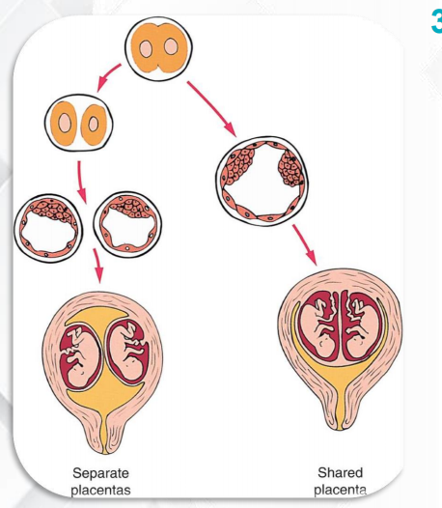
Q7: Dizygotic Twins.3
• Produced from two zygote (Fraternal twins) • Do not have striking similarities • May be of same or different sex • They have separate placenta and separate amniotic sac
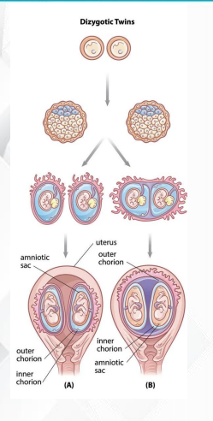
Q8: Three Functions Of Epididymis Of Human Male Reproductive organ.3
• Sperms from seminiferous tubules comes into a network of called rete testis
• Then into epididymis where:
• Sperms are store
• Muscular contraction propel sperm forward
Q9: Difference b/w synchrony and Asynchrony?
• Initially all the cells of embryo divide at the same time this is called synchrony
• As development proceeds, all cells don’t divide simultaneously. This is called asynchrony
Define human population growth 5 marks
- Population Growth • It is the increase in number of individuals in a population • Expanding population is the root cause of most environmental problems. • More population means more need for resource: food, urbanization, industrialization
- 2. Earth’s Carrying Capacity • How many human can be supported by earth? • Virtually all scientists agree that even 5 billion is more for earth to support with all facilities • Maximum carrying capacity of earth is may be 9 to 10 billion people
- 3. Age Structure • Age structure shows the proportion of individuals at prereproductive, reproductive and postreproductive stage • Developing countries have more infants means high birthrates • In contrast to human, in natural population high birthrate is accompanied with high mortality
Q10: What is avigan egg 3 or 5 marks
Structure of Avian Egg
- Egg Formation • In ovaries • Large amount of yolk • Mature egg released from ovaries • Comes into oviduct • Fertilization takes place in upper portion of oviduct
- 2. Egg White • Membranes and fluid collected around the egg while moving through oviduct • Water and albumin is deposited around the egg • This protect from desiccation and mechanical damage • Albumin is used for protection and source of nutrition • Two denser strands of albumin attached to the egg shell
- 3. Egg Shell • Shell gland secrete CaCO3 which deposit around the egg • It is also impregnated with proteins • Thousands of tiny pores (40-50µm)are for exchange of gases • Inside shell two membranes • Air pocke
- 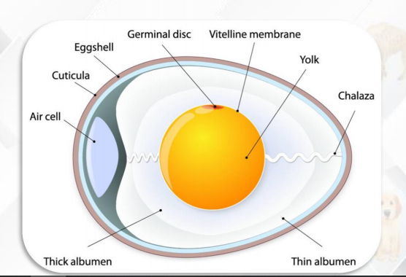
Q11: Write notes on energy flow? 5marks
- Energy Budget
• It is the balance sheet of energy gained and energy expenditure of an organism • An organism is an open thermodynamic system which exchange energy with its surrounding in three ways i.e., heat, work and potential energy of biomolecules • Energy budget allocation varies for ectotherms and endotherms. • Ectotherms rely on environment as heat source • Endotherms rely on metabolic heat to maintain body temperature
- Gross Productivity
• Total amount of energy assimilated by an organism when an animal eats food • When an animal eats, food passes through its gut and nutrients are absorbed
- Net Productivity
• Most of the energy assimilated is used in metabolic demands which include cellular metabolism and regulation of body temperature • So, net productivity is the amount of energy store in the form of biomass
4. Energy Flow
• Organisms require energy in one form or the other • Energy flow in an ecosystem is major factor for survival for great number of organisms • Source of energy is sunlight • Energy flows via food chain and food web • Flow is by 10% law • Energy flow is unidirectional
- Flow of material
• All elements essential for life are derived from environment • They make all form of molecules for life. • When animals die and their dead bodies are decomposed, these materials are recycled in the ecosystem • Nutrient flow in ecosystem in a cyclic way
Q12: Explain Coelom Formation
• Protostomes: Coelom is formed by splitting of mesoderm. This pattern is called schizocoelous.
• Deuterostome: Coelom is formed by out pouching of primitive gut (archenteron). This pattern is called enterocoelous.
Q13: Consumer
• Organisms which can not synthesize their food from inorganic compounds • They eat other organisms to get nutrition • All animals are consumers
Q14: Primary Consumers
• They are also called herbivores • These are the animals which feed on plants • E.g., • insects • grain eating birds • reptiles, birds and mammals which feed on leaves and other vegetation
Q15: Secondary Consumers
• Also called carnivores • These are the animals which feed on herbivores • E.g., lion, tiger, frog
Q16: Tertiary consumers
• These are the animals which feed on secondary consumers • E.g., a snake when eating a frog, a jaguar when hunting for a crocodile
Q17: Difference between Density independent factors and Density dependent factors
Population Density
• It is the number of individuals living per unit area. • Population density impact populations in predictable ways
Density-independent Factors
• These factors affect population regardless of their number • Weather conditions • Earth quake • Pollutants • Deforestation • Hurricane • Fire
Density-dependent Factors
These are the factors which are more severe when population density is high • Competition for resources • Disease • Predation • Parasitism
Q18:Spermatogenesis
• The process of sperms production in male gonads through meiosis is called spermatogenesis
2. Location and duration • Spermatogenesis takes place in testes • In human the entire process of spermatogenesis and its transportation takes about 3 months • However, it is different in different animals
3. Spermatogoium and Primary Spermatocytes • Testes contain diploid stem cells • Sperm mother cell is called spermatogomium • It enlarges in its size and become primary spermatocyte
4. Secondary Spermatocytes and Spermatids • Primary spermatocyte undergo meiotic cell division. • After meiosis-I two secondary spermatocytes are formed • Meiosis-II results in four haploid spermatids
5. From spermatids to sperms • Spermatids do not undergo any further cell division • They undergo morphological changes to produce sperms
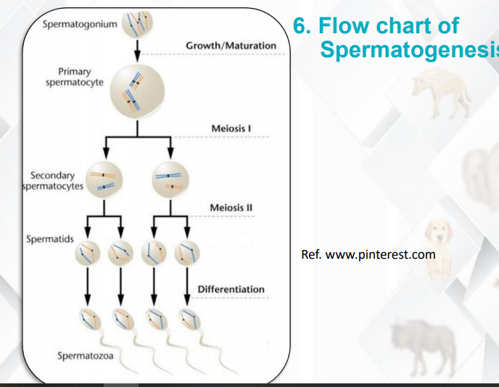

Q19: Gametogenesis OR Oogenesis
- Oogenesis • The process of egg production in female gonads through meiosis is called oogenesis
- 2. Location of Oogenesis • Oogenesis takes place in ovaries • Follicles are specific structures in which egg formation and maturation takes place
- 3. Oogoium and Primary Oocytes • Ovaries contain oogonia. • Oogonium increase its size ….primary oocyte • Primary oocyte is diploid cell with duplicated chromosome • Each primary oocyte will form 1 ovum and polar bodies after reductive division
- 4. Secondary Oocytes and Ovum • Primary oocyte undergo meiotic cell division. • After meiosis-I one secondary oocyte and one polar body is formed • Meiosis-II results in a haploid ootid and another polar body
- 4. Secondary Oocytes and Ovum • Ootid undergo differentiation process to form ovum
- 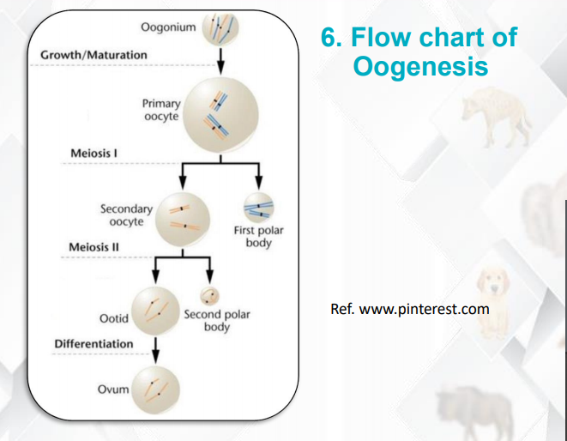

Q20: Differentiate between the Sprouter AND Seeders:
Types of Plants • Two types of plants
• Sprouters: dormant meristem, storage and intact root help to regenerate quickly
• Seeders: long lived seeds, germination induced by fire • Plants include toyon, chamise, poison oak, scrub oak, Yucca, Sumac
Q21: factores effecting on reproductive potential(5marks long)
Number of offspring produced
• Survival to reproductive age
• Reproductive period duration
• Length of time taken to maturity
Q22: plasmodstomes(not confirm)
Q23: Niche Diversification
• Competition between species may be reduced if resources are divided • One part of resources by one species and second part by other species • This mechanism is called niche diversification
Q24: Epigenesis Theory
• This theory gained popularity in mid 18th century • This theory says that embryo contain material from which embryo is gradually build • Much like a carpenter builds a building from nails, lumber and bricks
Q25: Food chain and its importance?
- Food Chain
• It is the sequence of organisms in an ecosystem where energy moves from one organism to the next organism • It tells us the sequence to eat and being eaten
- Grazing Food Chain
• It is the food chain that starts from the living green plants. • Green plants are eaten by herbivores which are eaten by carnivores • Such food chains are directly dependent on sunlight
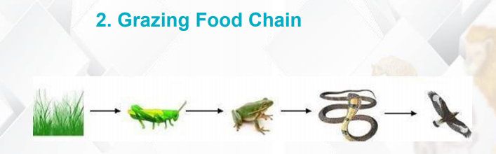
- Detritus Food Chain
• It is the food chain that starts from dead organic matter to microorganisms and then to organisms • They are little or not at all dependent on direct solar energy
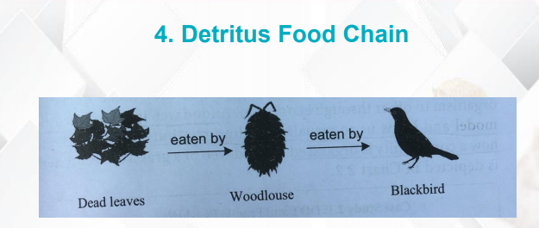
- Importance of Food Chain
• To understand the feeding relationships between organisms • To explore the energy flow mechanisms and matte circulation • To understand the problems of biomagnification
Q26:Neritic Ecosystem.2
• Neritic ecosystem extend from littoral zone to the edge of continental shelf • It is also called the shallow water
Q27: Enlist 5 types of ecological hierarchy?5
2. Ecological Hierarchy • It is the way in which ecological components interact with each other • There are five levels • Organism • Population • Community • Ecosystem • Biosphere
Organism
• Organism is the first level in ecological hierarchy • All the living things come at this level • E.g., human, lion, tiger, cow, tree, shrub • The way how organism interact with its environment is studied at this level
Population
• Group of organism of same species living at same geographical location at same time • At this level we study how the members of group live together and interact with each other
Community
• Groups of different species living together in a given area • The number of species represent the diversity of community • Community ecology include • Predation • Parasitism • Competition
Ecosystem
• It is the study of all population in a community and their physical environment • Biotic components and abiotic components • How living organism make the use of abiotic components • How they get energy • Effect of physical factors on organisms
Biosphere
• Biggest of all levels • All the area of earth and atmosphere occupied by living organisms • Main focus is on: • Geology • Climate • Water bodies • Latitude • Longitude
Q28: Disadvantage of sexual reproduction (5)
1. Advantages
a) Genetic Variability
• Genetic recombination • New combination of traits • This may help in changing environment or in case of disease
b) Foundation for Evolution
• Genetic variability is there • Variation is the foundation of evolution
c) Elimination of Deleterious Traits
• As there is genetic recombination • Deleterious mutation are eliminated
2. Disadvantages
a) Asexual animals
• Not feasible for animal which rely on asexual means only • Especially population with one sex only
b) Adaptive Gene Combination Dismantle
• In sexual reproduction new genetic combination arise • This will upset the already established adaptive gene combination
c) Wastage of energy
• Many of the gametes are not fertilized • This will cause a significant loss of energy
Q29: Difference in spiral and radial cleavage (3Mark's)
. Spiral Cleavage • It is pattern in which cells of animal pole are not exactly laying above the vegetal pole cells • Cleavage takes place at oblique angle forming a spiral pattern • Example: protostomes
Radial Cleavage • It is pattern in which cells of animal pole are exactly laying above the vegetal pole cells • Upper tier of cells is exactly on the lower tier of cells • Example: deurostomes
Q30: Explain meroblastic cleavage and Holoblastic Cleavage? 3marks
Meroblastic Cleavage
• Cleavage type in which egg is not completely divided into two cells • This is due to large amount of yolk • These embryo develop around or on top of yolk • Eggs of birds and reptiles
Holoblastic cleavage
• Cleavage type in which egg is completely divided into two cells • Egg contain little or moderate amount of yolk • Eggs of Amphibians, mammals, echinoderms, flatworms, nematodes
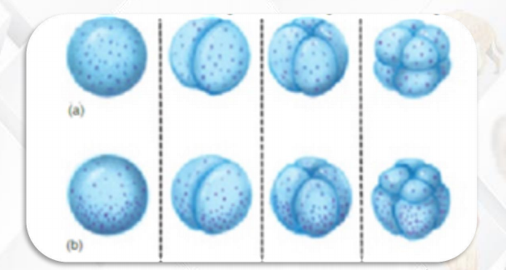
Q31: Difference between . Ectosymbiosis and Endosymbiosis?
. Ectosymbiosis • It is a symbiosis in which symbionts live on the body surface of the host or in the digestive tact • E.g., Lice, barnacles and cleaner fish
Endosymbiosis • It is the relationship in which one symbiont live within the tissue of other. • E.g., nitrogen fixing bacteria in root nodules, algae inside the corals
💫Discuss coriolis effects? 3marks
Q32: Coriolis Effect
• Biomes are distinct by climate, pattern of rainfall, temperature and solar radiations • Warm air at equator rises and move towards poles and cold air away from pole • The earth rotation deflect this air to right and left of the poles • The effect is called Coriolis effect
Q33: Primary Succession
• The process of succession in an area that was not supporting any life previously is called primary succession. • Ecological succession in a lake formed by glacier or land exposed by land sliding
Q34: Birth of modern embryology (2)
• Modern embryology emerged with the proposed germ layer theory • Embryo form 2-3 layers from which different body parts are formed
Q35: Deffernece. b/w. phtoautotrophes and chemtrouphes
Photoautotrophs • They use sunlight as energy source for the synthesis of food from inorganic compounds • Green plants, algae, and photosynthetic bacteria • Photosynthesis transform less than 1% of sunlight reaching to earth • 30% reflects back • 20% is absorbed by atmosphere • 50% absorbed by earth
Chemolithotrophs • They obtain energy by oxidizing inorganic compounds • Usually live in extreme environments • E.g., sulfur bacteria
Q36:Ecological Pyramids
• It is the graphical representation of relationship between organisms at different trophic levels of an ecosystem • Three most common types of pyramids: • Pyramid of number • Pyramid of biomass • Pyramid of energy
Pyramid of Numbers
• It is the graphical representation of total number of different organisms present at each trophic level • This shows the population of organisms in a food chain
Pyramid of Numbers Example
• In a grass land the survey was conducted to check the trophic structure. • Following data was obtained • Producers: 1.5 x 106 • Primary consumers: 2x105 • Secondary consumers: 9x104 • Tertiary consumers: 1
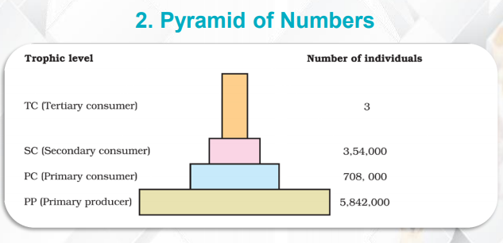
Pyramid of Biomass
• It is the representation of total mass of living matter present at each trophic level. • Biomass decrease at each ascending trophic level • Biomass is measured in grams of dry mass per square meter
Pyramid of Biomass Example
• In a pond the survey was conducted to check the trophic structure. • Following data was obtained • Producers: 809 g/m2 • Primary consumers: 37 g/m2 • Secondary consumers: 11 g/m2 • Tertiary consumers: 1.5 g/m2
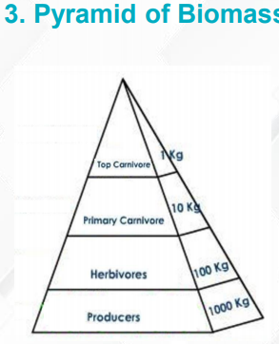
Pyramid of Energy
• It is the representation of total amount of energy present at each trophic level in an ecosystem • It is always upright • Energy pyramids help to compare the productivity of ecosystems.
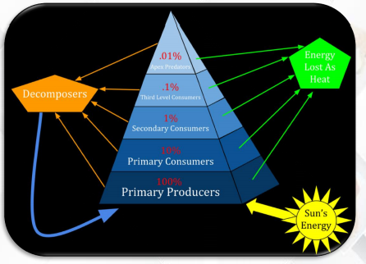

Q37: Biodiversity loss (5)…
Biodiversity of Earth
• More than 1.6 million • Estimate is 4 to 6 million • More accurate is between 8.7±1.3million
Threats to Biodiversity
• Biodiversity of all natural areas is threatened • Acid rain • Pollution • Urbanization • Agriculture • Human is exploiting 40% of earth net primary production • Habitat loss
Solutions
• Realization about biodiversity • 22nd May is World Biodiversity Day • A system of international ethics that value natural diversity
Q38: Define Decomposers
• These are the organisms which obtain energy by breaking down dead organic matter into simpler compounds • Also called saprotrophs

